PURE ST0RAGE

INTRODUCTION

**Pure Storage is a technology company that develops software products and all-flash data storage hardware. Pure Storage was established in 2009 and it was developing its products in stealth mode until 2011.**

**Pure Storage is an American publicly traded technology company headquartered in Mountain View, California, United States.**

**After that, the business saw a 50 percent increase in quarterly revenues and raised more than $470 million in venture financing before going public in 2015. At first, Pure Storage used generic flash storage hardware and built the software for storage controllers. In 2015, Pure Storage completed the development of its own exclusive flash storage hardware.**

**Project summary**

|  |  |
| --- | --- |
| **WEBSITE** | **PROJECT WEBSITE LINK** |
| ORAGIZATAION: PURE STORAGE | **https://www.purestorage.com/** |
| **LICENSE: PURE STORAGE** | **ENC 740.17(B)(1)** |
| **OPEN / PROPRIETARY** | **PROPRIETARY** |
| **SOURCE PATH (IF OPEN SOURCE)** | **DATABASE SOURCE** |
| **BRIFE DESCRIPTION** | **Pure Storage® is a leading provider of enterprise-grade, all-flash block, file, and object storage. Pure delivers a Modern Data Experience™, allowing you to rely on innovative, cloud-ready solutions and the best experience in technology to transform data into powerful outcomes.** |

**PROJECT DETAILS**

1. KEY FEATURES

* **The speed at which you can create new ideas.**
* **The speed at which you can deploy those ideas.**
* **The speed at which you can measure the effectiveness of those ideas.**
* **The speed at which you can respond to your customers.**
* **The speed at which you can respond to opportunity.**

2.ARCHITECTURE

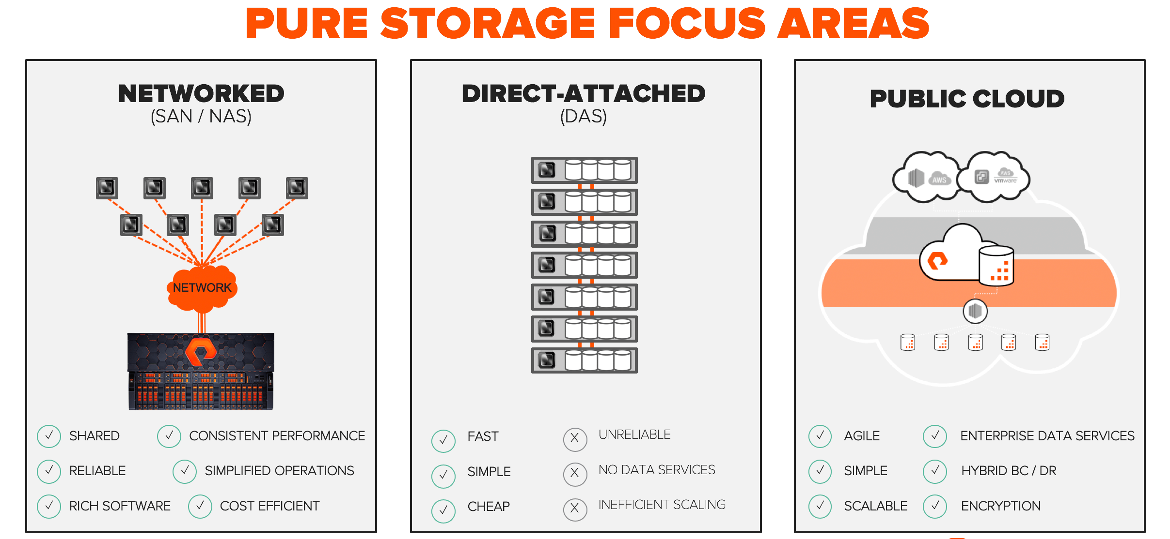

* **NETWORKED**
* **DIRECT – ATTACHED**
* **PUBLIC CLOUD**

Applications that process this data have very different requirements, which created silos.  Each application required its own tailored storage architecture resulting in different user experiences.  At pure we focused on alleviating the challenges of networked storage (San and nas) with flash array™ and flash blade™ by building a product from the ground up on flash, not disk.  We recently debuted cloud block store, a new series of cloud data services to enhance the public cloud.  But we didn’t focus much on das which runs many of the analytics and highly concurrent applications of today.

3. CURRENT USAGE

Industry leading all-flash data storage systems, software and products. Effortless acceleration and consolidation for all your workloads. Evergreen Storage. All-Flash Array. Enterprise Storage. Hybrid Cloud. VDI Deployment. All Flash Storage.

4.TECHNICAL DETAILS

The Pure Technical Services team is focused on you and your data with 24/7/365 global reach. With a Net Promoter Score (NPS) in the top 1% of B2B companies and CSAT scores above 97%, Pure is focused on providing the best customer experience in the industry.

[Get Prue’s Customer Support Guide](https://www.purestorage.com/docs.html?item=/type/pdf/subtype/doc/path/content/dam/pdf/en/legal/pure-support-guide.pdf/context/services/technical.html)

OTHER INFORMATION

* **Fast by Design**

1. All-NV Me performance across the portfolio
2. Faster time-to-insights and time-to-market
3. Fast, non-disruptive upgrades

* **Smart Simplicity**

1. Plug-and-play setup
2. Pure1 AI-powered predictive platform management
3. SaaS-based data management platform
4. Built-in business continuity

* **Risk-free Innovation**

1. Planned downtime-free, data-in-place, forklift-free upgrades
2. On-premises and cloud solutions
3. The most choice in flexible storage subscriptions

* **Always-improving Data Services**

1. 8:1 cost-saving total efficiency
2. Ransomware and disaster recovery built-in
3. 99.9999% uptime, including upgrades

* **All-inclusive vs. Expensive Add-ons**

Pure’s software driven storage and subscriptions provide all-inclusive, enterprise-class functionality. Get the features you need to secure, accelerate, and manage your data—including future enhancements—with no additional cost.

### Pure Storage vs. Competitors

|  |  |  |  |  |
| --- | --- | --- | --- | --- |
| Feature | Pure Storage  Evergreen//Forever | Dell EMC  Future-Proof for Power Store Only | NetApp (eliminated hardware upgrade program) | HPE Primera/Nimble Timeless |
| All-Inclusive Software Subscription | All array features, now and in future | Only select software included*** | Many features available only in select bundles | Limited features |
| Guaranteed Effective Capacity | Right Size Guarantee* | No capacity guarantee | No capacity guarantee | No capacity guarantee |
| Non-Disruptive HW and SW Upgrades Across Generations | Truly non-disruptive, data-in-place, modular upgrades | Announced, however vendor has history of disruptive upgrades | Disruptive upgrades if more than 50% controller utilization | Limited NDU (not across generations, Nimble only) |
| Included Controller Upgrades to Latest Generation | Free Every Three included controller upgrades** | One-time controller upgrade to Next-gen ONLY **** | None | One-time controller credit |
| No-limit Anytime Controller Upgrades | Upgrade Flex (anytime 100% trade-in credit) ** | One-time controller upgrade to Next-gen or Next-model ONLY *** | None | None |
| Anytime Media  Upgrade/Trade-in | Capacity Consolidation** | No media trade-in | None | One-time media upgrade (Nimble only, credit value is at vendor discretion) |
| Proven Record of Delivering on Promises Upgrade/Trade-in | >10,000 controller upgrades, without disruption or re-buy | New program, unproven | None | New program, unproven |